**COMSATS UNIVERSITY ISLAMABAD LAHORE CAMPUS**

**Registration no.(FA24-BBA-131).**

**Muhammad Asif**

**Mam. Mufeeza Manzoor.**

**Submitted to:**

**Submitted By:**

**Exercise 1:**

Make a list.

**Program:**

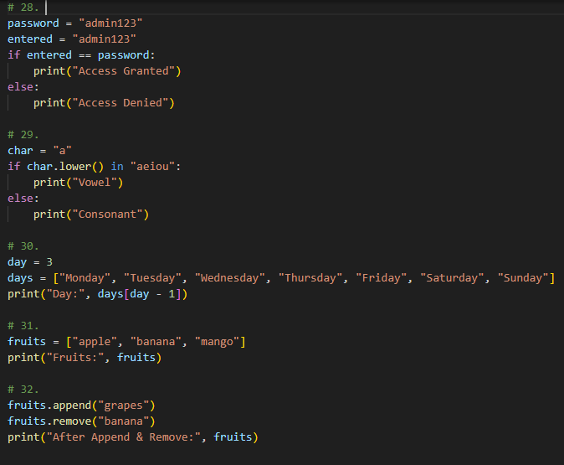

**Output:**



